**Smart Child Saving Pool Management**

**Phase II**

**Dr. Yasser Gadallah**

**Hassan Mohamed 900202476**

**Ahmed Elsousy 900202388**

**Hammad Omar 900183939**

**Sara Hassan 900193688**

Table of Contents

Contents

Motivation 3

Description of Components 4

System Architecture and Interaction 4

Block diagram 5

Financial Projections 6

Shipping: 7

Installation: 7

Contributions: 7

Final Design Notes: 8

References 8

# Motivation

Every year, tragic incidents of childhood drowning occur around the world, devastating families, and communities. Despite efforts to prevent such accidents, they persist as a significant public health concern. The alarming reality is that drowning is one of the leading causes of death among young children, especially those under the age of five. These incidents often happen suddenly and silently, leaving little time for intervention.

Imagine a world where we could provide caregivers with an extra layer of protection, where the moment a child falls into water, swift action is taken to prevent tragedy.

This is the inspiration behind our proposed project: developing a cutting-edge wireless sensor network system embedded within a wearable necklace designed specifically for young children. This necklace will be equipped with sensors capable of detecting immersion in water and promptly alerting caregivers or nearby authorities in real-time.

By leveraging the latest advancements in wireless sensor technology, our project aims to revolutionize drowning prevention efforts. Through meticulous design and rigorous testing, we seek to create a reliable and robust system that can accurately detect water immersion while minimizing false alarms.

The potential impact of this project is profound. Not only does it have the potential to save countless lives, but it also underscores the commitment to innovation and social responsibility. By empowering caregivers with a proactive tool to prevent childhood drowning, we can help create safer environments for our most vulnerable population.

# Description of Components

* Humidity Sensor: Detects the change in humidity of the environment to detect whether the baby is inside or outside the pool to prevent drowning incidents.
* Safety Monitoring & Alert System: Processes data from humidity sensor and triggers alerts if a safety risk is detected.
* Alarm System (Audiovisual): Alerts users to safety risks or system issues.
* Wireless Communication & Control Unit: Manages data transmission between sensors, buzzer, and the user interface. It also processes control logic.
* User Interface (App/Web Portal): Allows users to monitor and receive notifications.

# System Architecture and Interaction

The system architecture utilizes a layered approach to facilitate real-time monitoring and alerting for drowning prevention. The architecture is realized through the interconnection of a wearable device, a home-based alert system, and a remote notification interface. Here's the breakdown according to the block diagram:

**1. Wearable Device Layer**

* **Humidity Sensor (DHT-11):** Attached to the ESP8266 module within the necklace, this sensor is responsible for detecting changes in humidity, indicating potential immersion in water.
* **ESP8266 Microcontroller:** This is the core processor within the necklace that continuously reads the data from the humidity sensor via the D2 pin. It has built-in Wi-Fi capability, enabling it to connect to the internet through the Blynk Cloud service.

**2. Home Alert System Layer**

* **ESP8266-01 WiFi Module:** Acts as a bridge between the necklace and the home alert system. It receives signals from the ESP8266 in the necklace and forwards the data to the Arduino.
* **Arduino Microcontroller:** This microcontroller is the central unit at home. It processes the data received from the ESP8266-01 module through RX-TX (serial communication) and determines if an alert should be triggered.
* **Buzzer (connected to pin D8):** The Arduino activates the buzzer if the moisture level exceeds the threshold, indicating the child is in the water, producing an audible alarm.
* **Alarm LEDs (connected to pin D9):** Alongside the buzzer, visual alerts are provided by LEDs that flash when the Arduino activates the alarm system.

**3. Remote Notification Layer**

* **Blynk IoT App:** A mobile application that allows the caregiver to monitor the system remotely. The ESP8266 in the necklace sends data to the Blynk Cloud, which can be accessed in real-time via the app.
* **Phone Alert Notification:** In the event of an alarm, the Blynk App sends a push notification to the caregiver's smartphone, alerting them immediately of the potential danger.

Figure 1: Blynk Alert Notification Example

**System Interaction Flow**

1. **Monitoring:** The humidity sensor on the necklace continuously measures the surrounding humidity levels and sends this data to the ESP8266 microcontroller.
2. **Data Processing:** The ESP8266 microcontroller analyzes the humidity data. If it detects an immersion event, it sends a signal to the ESP8266-01 module at home via Wi-Fi and to the Blynk Cloud.
3. **Home Alert Activation:** Upon receiving the immersion signal, the ESP8266-01 module forwards the data to the Arduino, which then triggers the buzzer and alarm LEDs to alert anyone within the home.
4. **Remote Notification:** Simultaneously, the Blynk Cloud processes the signal from the necklace and sends a push notification to the caregiver’s smartphone, ensuring that they are informed of the incident regardless of their location.
5. **Caregiver Response:** The caregiver receives the smartphone notification and can act immediately to ensure the child’s safety. The Blynk IoT App also allows the caregiver to monitor the status of the device and the child continuously.

# Block diagram

This diagram provides a high-level overview of the system's architecture. Each block represents a critical component or function within the IoT project, illustrating how they interact to ensure the baby's safety.

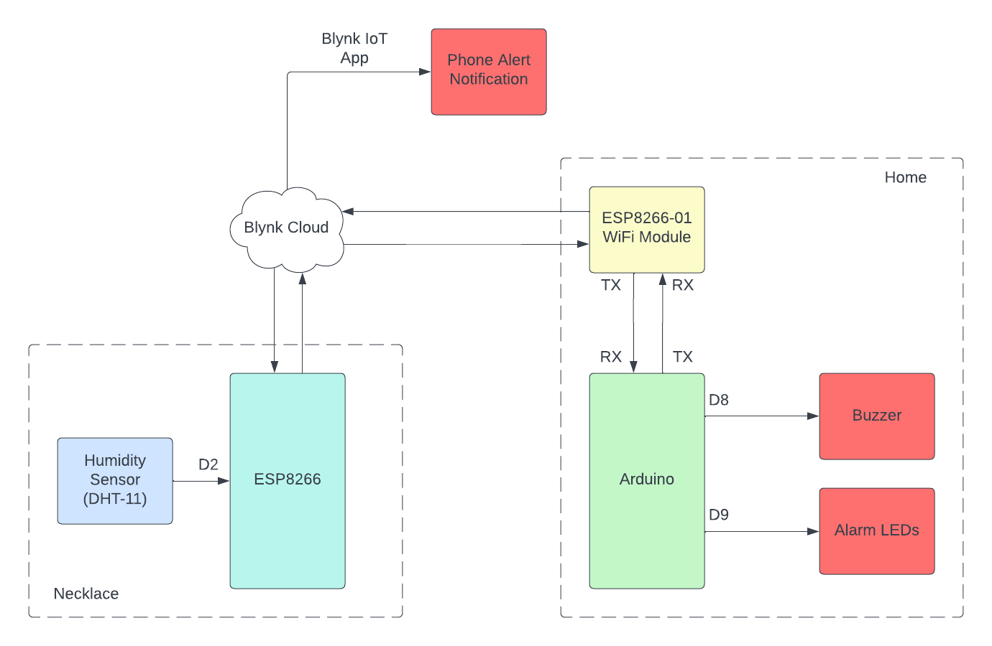

# Financial Projections

# Shipping:

The box will contain the following:

* A plastic box that houses the alarm and lighting systems control unit
* A wearable necklace that contains the sensor
* A quick and simple installation guide for the user

# Installation:

The installation process is simple and will be done via the user. The user can refer back to the installation guide found inside the box for any assistance needed.

# Contributions:

**Ahmed Elsousy: Software and Wi-Fi integration**

**Hassan Mohamed: Hardware integration and selection**

**Hammad Omar: Hardware integration and testing**

**Sara Hassan: Software and sensor logic**

# Final Design Notes:

This design is a prototype for the product; hence development boards were used. The final product will be on PCBs and in a more compact casing, making them more user friendly.

# References

<https://www.redcross.org/get-help/how-to-prepare-for-emergencies/types-of-emergencies/water-safety/drowning-prevention-and-facts.html>

<https://www.cdc.gov/drowning/facts/index.html>

<https://www.childrenssafetynetwork.org/infographics/facts-childhood-drowning>